  - Exploring Art, Layout, and Spiritual Function in Catholic Worship
Across the world, religions create spaces dedicated to connecting the human and the divine. Among these, the Roman Catholic altar stands as a profound example of how appearance and layout are intricately linked to religious functions and beliefs. The altar serves not only as a place for ritual but as a canvas for visual theology that draws worshippers into the core mysteries of faith.
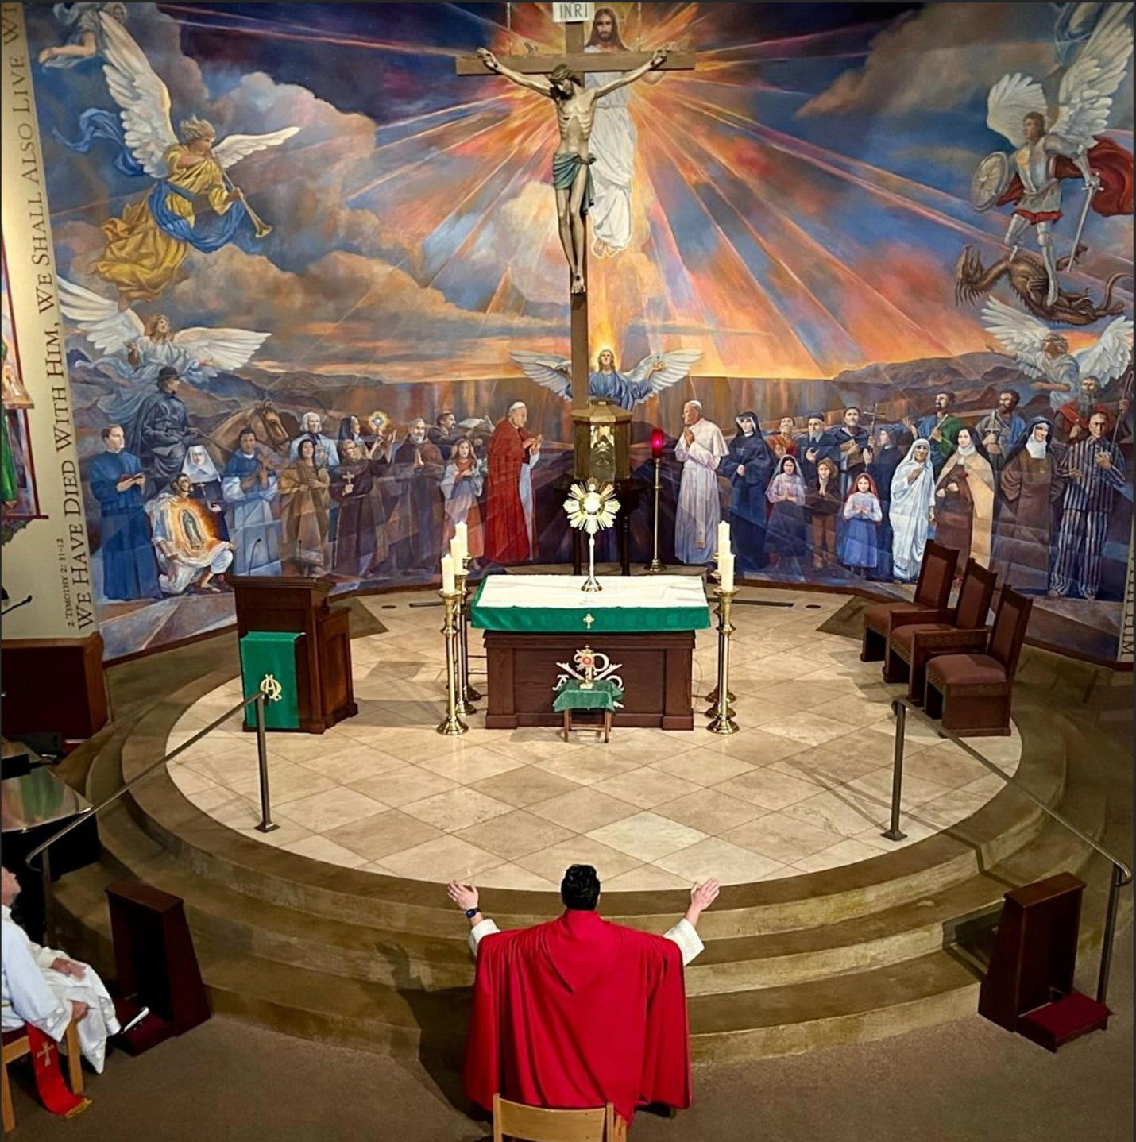
The altar’s central feature is the crucifix, depicting Jesus Christ’s sacrifice at the heart of Christian belief. This image is not chosen arbitrarily; its location and prominence directly reflect the Catholic understanding of Christ’s atonement as the focal point of worship. Above Jesus’ head, the inscription INRI identifies him as “Jesus of Nazareth, King of the Jews,” reminding the faithful of both his earthly identity and spiritual kingship. Golden rays emanate from the crucifix, visually reinforcing the doctrine that salvation and divine glory flow from Christ’s sacrifice. The use of radiant light around the crucifix is symbolic, guiding the congregation’s attention and evoking a sense of awe and reverence.
Beneath the crucifix, the altar table holds the monstrance, which displays the Blessed Sacrament during Eucharistic adoration. This structure is unique in Catholic worship, as it is both the physical and spiritual center of the liturgy. The monstrance’s ornate design draws the eye, emphasizing the importance of the Eucharist, believed to be the real presence of Christ. Flanking the altar, candles burn steadily, representing Christ as the light of the world and reinforcing the spiritual illumination sought by believers.
Surrounding the altar, the mural expands the sacred narrative. Angels in varied roles such as heralding, guiding, and defending connect worshippers to the celestial realm, while saints, martyrs, clergy, nuns, and laypeople gather around the cross. This visual gathering illustrates the Communion of Saints, a core Catholic belief that the faithful are united across time and place through Christ. The figures of the Virgin Mary and St. John the Apostle, placed near the cross, serve as witnesses to Christ’s crucifixion, anchoring the scene in biblical tradition and inviting worshippers to contemplate their own witness to faith.
On the wall, the scripture “IF WE HAVE DIED WITH HIM, WE SHALL ALSO LIVE WITH HIM” (2 Timothy 2:11) is inscribed. Its placement is intentional, reinforcing the message of hope and resurrection integral to the Catholic worldview. The artistic style is realistic, with vivid colors and a composition that directs all eyes toward the crucified Christ, ensuring that the central message is never lost amid the details.
The layout and appearance of the Roman Catholic altar are inseparable from its religious uses. Every element, from the crucifix and monstrance to the murals and inscriptions, serves to immerse the faithful in the mysteries of faith, connecting heaven and earth in a unified vision of salvation. These unique structures and characteristics transform the altar into more than just a physical space; it becomes a sacred environment where believers encounter the divine, experience communal worship, and participate in rituals that define their spiritual lives.

